TASK-6

1.

var numsArr = [ 1, 2, 3, 4, 5, 6, 7, 8, 9, 10, 11];

var new_string = "";

for (var i = 0; i < 11; i++) {

new_string += numsArr[i]

}

console.log(new_string);

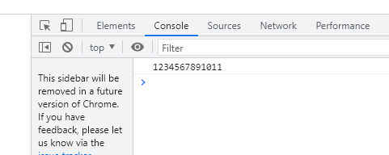

2.

var numsArr = [ 1, 2, 3, 4, 5, 6, 7, 8, 9, 10, 11];

var new_string = " ";

for (var i = 0; i < 11; i++) {

new_string += numsArr[i] + ","

}

console.log(new_string);

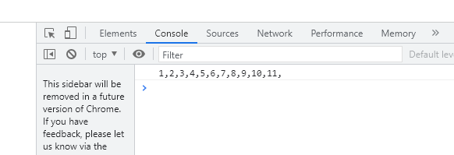

3.

var new_string = " ";

let numsArr=[]

for (var i = 11; i > 0; i-- ) {

new_string += numsArr[i]

}

console.log(new_string);

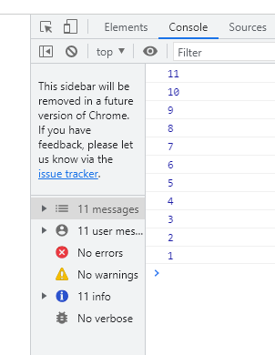

4.

var numsArr = [ 1, 2, 3, 4, 5, 6, 7, 8, 9, 10, 11];

var even;

for (var i = 0; i <=10; i++) {

if(numsArr[i] %2 != 0 )

{

console.log(numsArr[i],"even,")

}

}

var numsArr = [ 1, 2, 3, 4, 5, 6, 7, 8, 9, 10, 11];

var even;

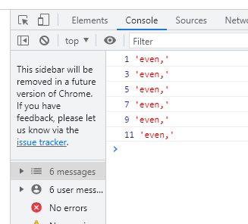

5.

var numsArr = [ 1, 2, 3, 4, 5, 6, 7, 8, 9, 10, 11];

for (var i = 0; i <=10; i++) {

if(numsArr[i] %2 === 0 )

{

console.log(numsArr[i],"even");

}

}

Output:

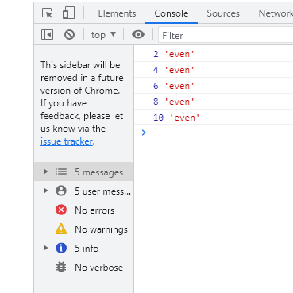

6.

var numsArr = [ 1, 2, 3, 4, 5, 6, 7, 8, 9, 10, 11];

var sum1=0;

for (var i = 0; i <=10; i++) {

sum1 += numsArr[i];

}

console.log(sum1)

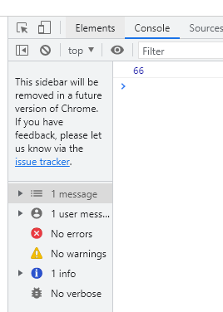

7.

var numsArr = [ 1, 2, 3, 4, 5, 6, 7, 8, 9, 10, 11];

var sum=0;

for (var i = 0; i <=10; i++){

if(numsArr[i] %2 === 0){

sum += numsArr[i]

}}

console.log(sum)

OUTPUT:

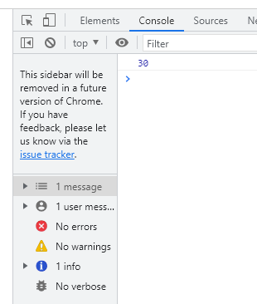

8.

var numsArr = [ 1, 2, 3, 4, 5, 6, 7, 8, 9, 10, 11];

var sum=100;

for (var i = 0; i <=10; i++) {

if(numsArr[i]%2===0)

{

sum += numsArr[i]

}

else

{

sum -= numsArr[i]

}

}

console.log(sum);

OUTPUT:]

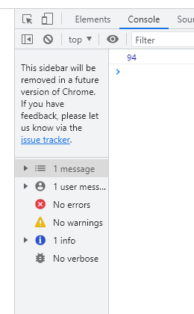

9.

var numsArr = [[1, 2, 3, 4,5],[6,7,8,9,10,11]]

// var numsArr1=[6, 7, 8, 9, 10, 11]

for(var i=0;i<numsArr.length;i++){

console.log( numsArr[i])

}

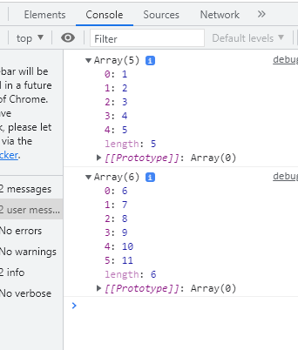

10.

var numsArr = [[1, 2, 3, 4, 5, 6, 7, 8, 9, 10, 11]];

for (var i = 0; i < numsArr.length; i++) {

let con=numsArr[i]

console.log(con.join(''))}

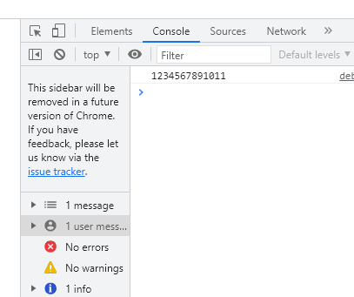

11

var numsArr = [[1, 2, 3, 4, 5],[ 6, 7, 8, 9, 10, 11]];

var str_all=0;

var Even=0;

for (var i = 0; i < numsArr.length; i++) {

var inner_array = numsArr[i];

for(var j = i ; j < inner_array.length;j++ )

if(numsArr[j] %2 != 0 )

{

numsArr= Even;

}

}

console.log(numsArr);